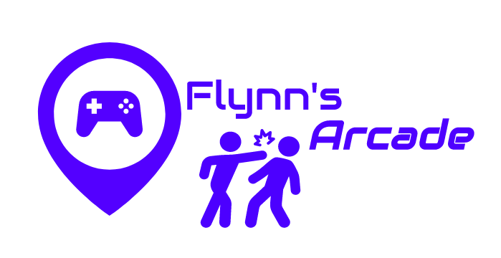

Flynn’s Arcade

portfolio

Mohamed Jebara | IST |28/08/2019

Table of Contents

Design Brief 2

Criteria 2

**Area of Investigation** 3

Comparison of Website Creation 4

Notepad ++ 5

Adobe Dreamweaver 5

Design Sketches and Logo 6

# Design Brief

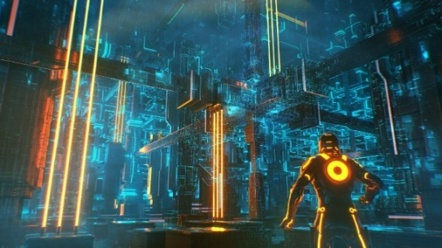Flynn’s Arcade has been slowly losing money as the trend for accessing video games has moved away from social video game arcades to at home and video game consoles such as the Atari Commodore Flynn wants to reposition his business as a venue for selling new games and trading used games. Flynn wants you to design and create ‘alpha phase’ website that communicates his new business model.

## Criteria

* Design a website which suits the design brief
* Make a website which suits colour palette
* Provide a detailed portfolio which suits design brief
* Make an “alpha website”
* Use HTML and CSS for coding
* Produce a substantial amount of work

# **Area of Investigation**

(Research)

#### **Kevin Flynn**

Paramus was his hometown and was born 1949. Kevin Flynn is a computer programmer who is the creator of some of the best-selling video games for like vice squad, Space Paranoids, Matrix Blaster and light cycles. He got fired, soon after and made his own video, Tron which was based on his own experiences inside the computer world. His wife passed away in 1985. Flynn began to focus all of his efforts on making films and games that would make a big difference. This was a huge success and it gained a lot of popularity.

**Appearances**

**Tron**

A film made in 1982, Kevin Flynn makes many attempts to hack into ENCOM because they stabbed him in the back and stole his genius. He there related his real experiences with a film. “Tron” went on to win Saturn Award for Best Costume Design

**Data communications and its Implication**

Data communications (DC) is the way toward utilizing figuring and correspondence advancements to move information starting with one spot then onto the next, and the other way around. It empowers the development of electronic or advanced information between at least two hubs, paying little respect to geological area, innovative medium or information content

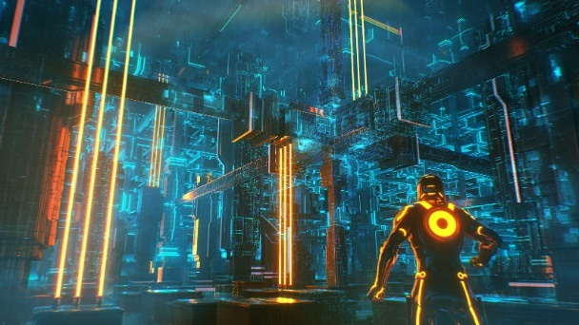Flynn’s design aesthetic is mostly made up of dark settings with neon lights which looks like this:

Web creation tools usually have a drag-and-drop interface that lets you drag-and-drop things into your website. Wix, a website builder, has a visual drag-and-drop interface. A CMS like Wordpress doesn't have a face. An IDE usually has a code editor, gotten from through one graphical user interface.

## Comparison of Website Creation



Wix’s is an easy way to create a professional website without having to know a lines of code. It has drag and drop which make web design so much quicker and convenient.With hundreds of templates and great tools Wix lets you advertise and sell through your site. This web creation tool is said to be Beginner-friendly. Wix can be used for things such as portfolios and websites. Available from 10$ per month.

Weebly is not as advanced as Wix and it is a lot simpler and easier to use than most web creation tool. Weebly has a very clear interface and is for less professional web creations and beginners. With weebly most people are able to create websites and make them available. Avalable from $15 per month

## Notepad ++

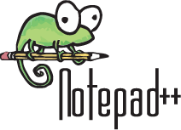To code our websites we used notepad++. Note pad++ is software used on Microsoft windows which is used as a source code editor and text editor. It is very useful for coding websites. There is also no money purchase for this software. Notepad++ is created to replace Microsoft Notepad.

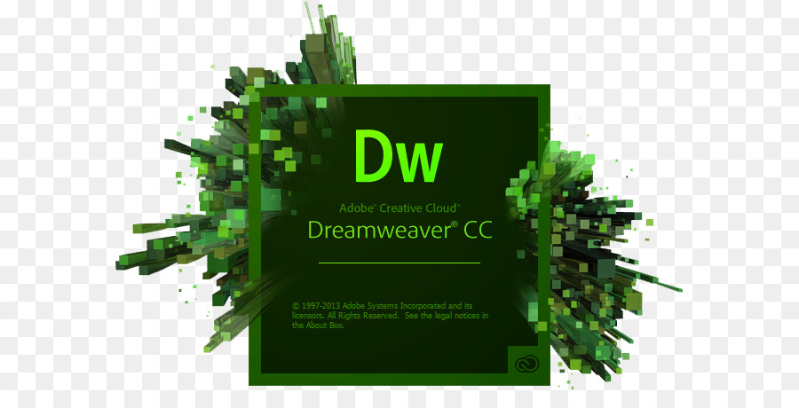

## Adobe Dreamweaver

Adobe Dreamweaver is from Adobe and is web creation software. It was created in 1997. Adobe Dreamweaver is available on Mac OS and Microsoft windows. It is the most complete toolset for professional website developers. With Adobe Dreamweaver you code, work on websites and create stuff. Available at $29.99 per month.

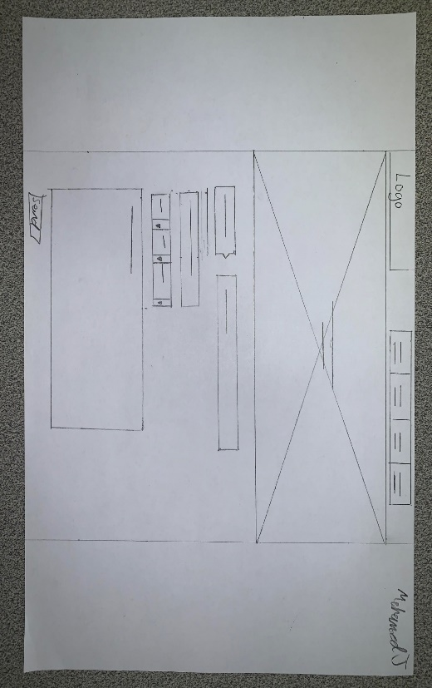

# Design Sketches and Logo

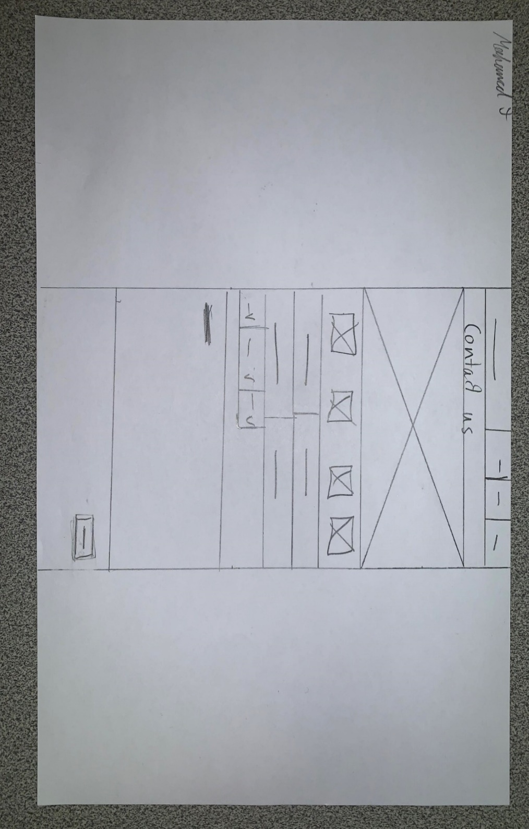



My website design sketches are inspired by the JB-HI-FI website store. During class we were told to do a rough copy of the format of the website on different devices. The first one was from a desktop perspective and the second sketch was from a phone perspective. My feedback from peers was that it was very neat and looked today. Another person said the phone perspective was too wide which I agreed with. It looks more like onto the tablet size then phone size.

My logo matches my colour palette. The place my logo was produced on a website called “LogoMakr” (<https://logomakr.com/>). The combat stick people are inspired by the fight scenes in the film “Tron” which is closely related with Kevin Flynn. The image on the far left of the logo represents a game controller which closely relates with an arcade. The second sketch is a contact us page which I didn’t end up doing in my website. The last difference is that my sketch looked more compact compared to my actual website.

The final result for my website was very different compared to what I expected. My website had a lot less buttons and mostly ended up looking very basic compared to my sketches, which is quite significant. Here is a comparison:

DESIGN CHANGES

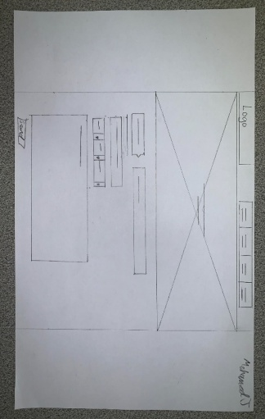

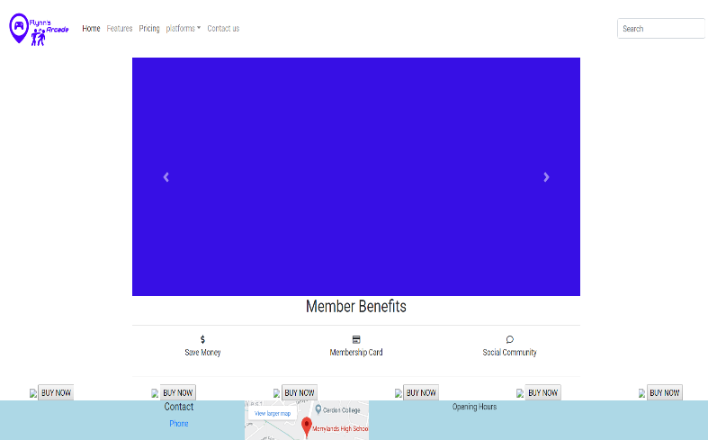

My website also had a slider that goes across the page edge to edge but on my design sketch it had a better looking slider that left space on the sides of the screen for a background or further promotions. My website also has no message system that is actually functional but it is rather just a button with no functionality. My website also went from the edge of the screen to the other whereas my sketch design leaves space for special advertisement or background which can be beneficial as it improves the overall look of the website and how it is portrayed. My design sketch looked a lot better in terms of how everything was set out compared to my final version of my website. My website has the logo in the top corner instead of in line with everything else



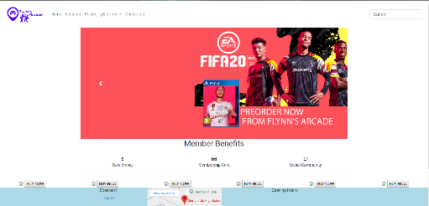

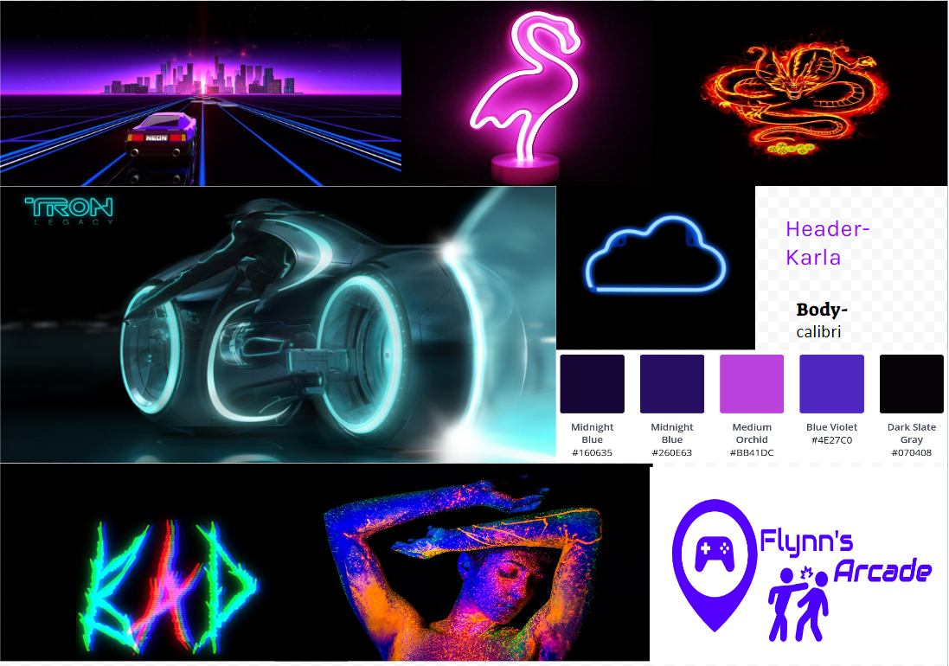My Mood board is heavily inspired by the particularly unique neon lighting shown pretty illuminating the generally dark world of Tron; neon lighting, which is quite significant. I specifically had a mixture of shades of basically purple throughout my website, which made it look very basically unique and particularly match very well with my colour palette which for all intents and purposes is part of the criteria.

Colour Palette

EVALUATION

The fairly good features for my website actually are that it for all intents and purposes has a slider with indicators which transition smoothly at the right speed. There are also particularly social media icons at the bottom of the page which are actually links to Facebook, Instagram, and YouTube etc. Another basically good feature on my website is that it matches my colour palette. The logo looked very smooth and slick in the top corner. It suited my website design and also my colour palette.

This website I made looked too dodgy for anyone to buy anything off of because of its lack of professionalism. I personally wouldn’t even think about buying anything from a website like mine. There aren’t even products or a purchasing system anyway. There was also a lack of technicality in my website. Everything looked so basic and half the buttons were there just for the sake of being there. For example the 3 button that said “save money”, “social community” and “membership” didn’t actually have any sort of functionality. Another fault on my website is that I only used one slider. The first slider was a picture of many console games and the logo but the rest were nothing but random colour.

In the future ways I would improve my design is toad some products on it so it would look more appealing to the audience and looks more legit. Also another way would be to put a contact system for reviews and complaints. That would make my website seem more professional. The technicality is really bad on my website that next time I want to add an actual search system for the convenience of the person visiting the website and can’t find anything on the page. This would make the experience on my website a lot more pleasant for impatient people. Furthermore I would change the drop bar into a different style because it’s ugly and looks terrible. It looks to messy and just covers stuff when you press them. The sliders only had one actual picture. I’m assuming if I could do it again I would add more because when it switch automatically it changed into a random colour and made the whole website look dodgy whereas if I had a full set of sliders, my website will keep a consistent look instead of sustaining that for just one slider out of the five. Another improvement I would have made to my web design is to make it more flexible with other devices as some problems appeared when you switched platforms in the control center. By doing this my website will once again seem more professional and legit

Overall I enjoyed this assessment task and hopefully it can develop into bigger and better things

<https://tron.fandom.com/wiki/Kevin_Flynn>

<https://www.shivarweb.com/4793/weebly-review/>

Bibliography

<https://www.shivarweb.com/4793/weebly-review/>

<https://www.quora.com/Is-it-a-good-idea-to-use-Dreamweaver-to-build-websites>

<https://www.elegantthemes.com/blog/resources/notepad-review-a-powerful-free-code-editor-packed-with-features>

<https://tron.fandom.com/wiki/Kevin_Flynn>

<https://disney.fandom.com/wiki/Kevin_Flynn>

<https://logomakr.com/>

<https://www.wix.com/>

<https://www.weebly.com/au>